**Experiment 1.2 Paul Thomas 30 S3 CSB**

**Program**

| class frequency {  public static void main (String[] args) {  String Str = args[0];  System.out.println("Given String is " + args[0]);  char ch[]= Str.toCharArray();  int []freq = new int[Str.length()];  int i, j;  for(i=0; i<Str.length(); i++){  freq[i]=1;  for(j=i+1; j<Str.length();j++){  if(ch[i]==ch[j]){  freq[i]++;  ch[j]=0;  }  }  }  System.out.println("Character and their corresponding frequency : ");  for(i=0; i<freq.length; i++){  if(ch[i]!='\0' && ch[i]!='0'){  System.out.println(ch[i] + "=" + freq[i]);  }  }  }  } |
| --- |

**Program**

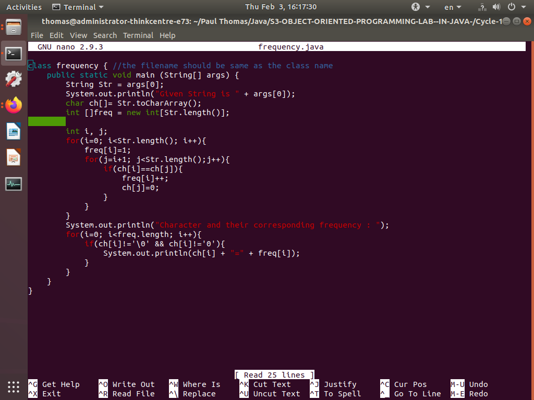

**Output**

